|  |  |  |  |  |  |
| --- | --- | --- | --- | --- | --- |
| Date | 25-Nov-22 | | | Tester Name | Mayuri Patel |
| Environment | Penfax - Test | | | Login used |  |
| Operating System | Select OS | Version: | Update: | | |
| Software Used | Select Software | Version: | Update: | | |
| Select Software | Version: | Update: | | |
| Release version | 22.4.1 | | | | |
| Title |  | | | | |
| Test Type | Regression | | | | |
| Test Scenario | Process a non-resident payment for Australia (add another country) | | | | |
|  |  | | | | |
| Expected Results |  | | | | |
| Pass/Fail | Pass | | | JIRA# | N/A |

Describe your steps with screenshots:

Search for a MEPP terminated member who currently lives in Australia

Open that member Profile

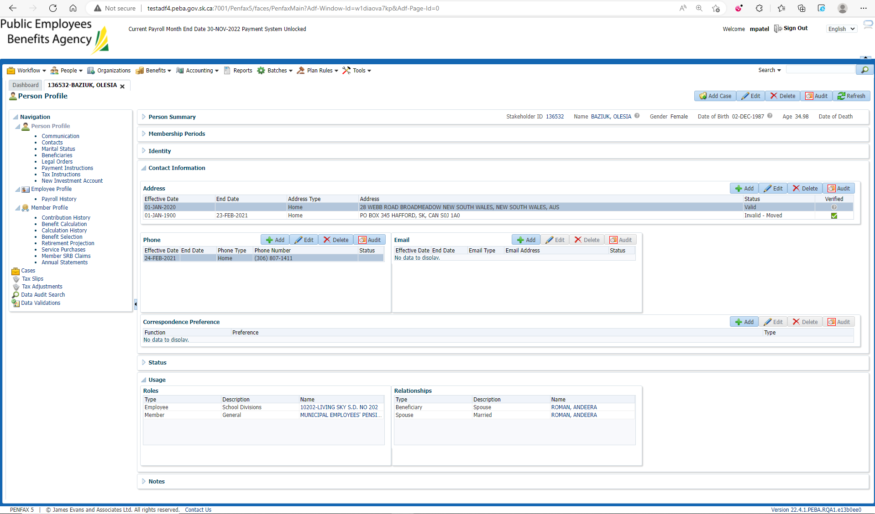

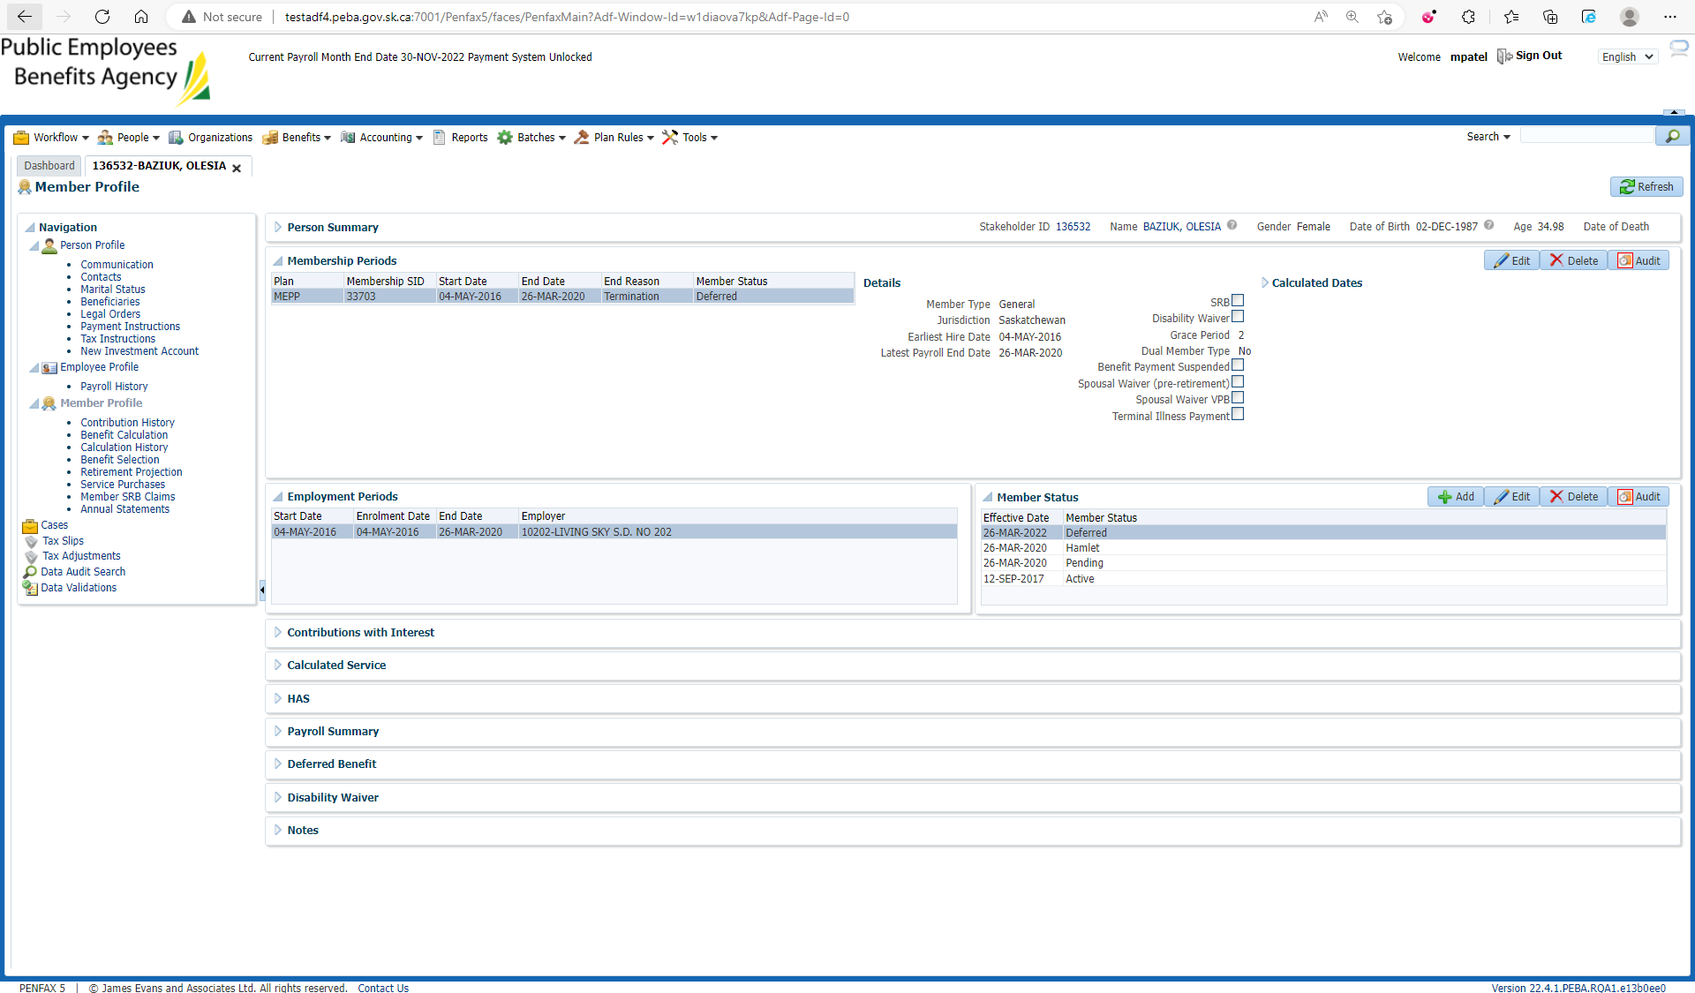

Add New Tax Instruction

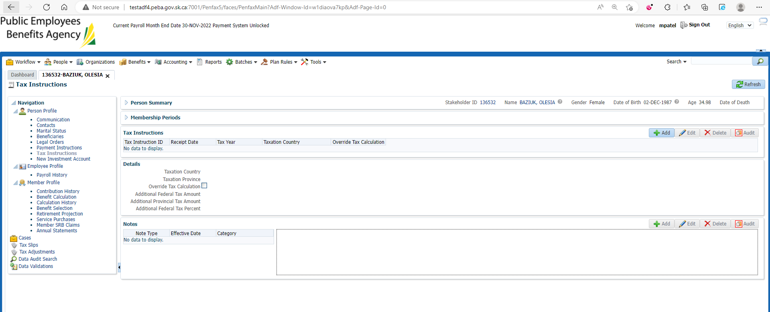

Enter Taxation Country to Australia and Save

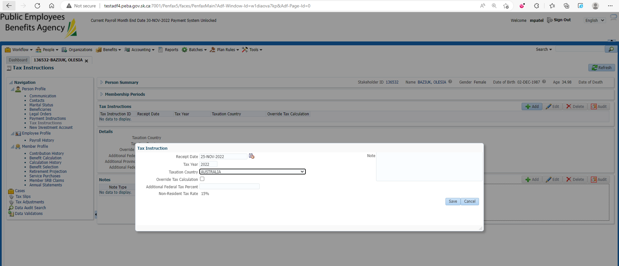

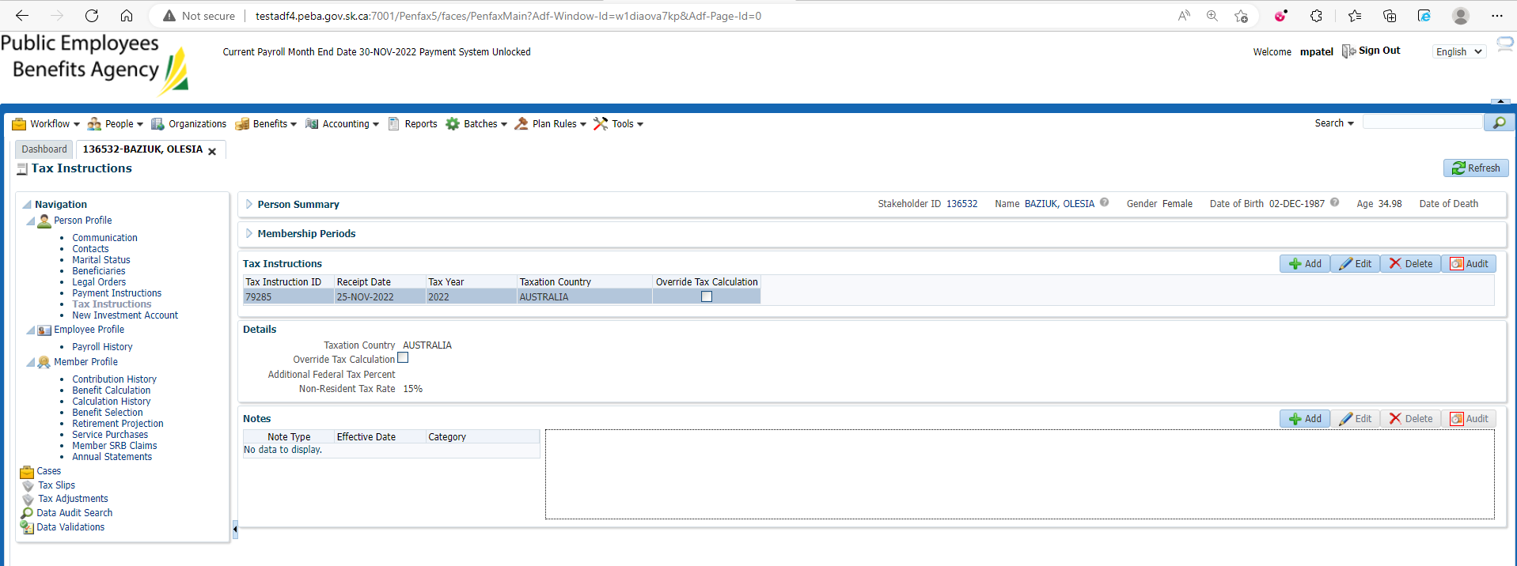

Add new Payment Instruction

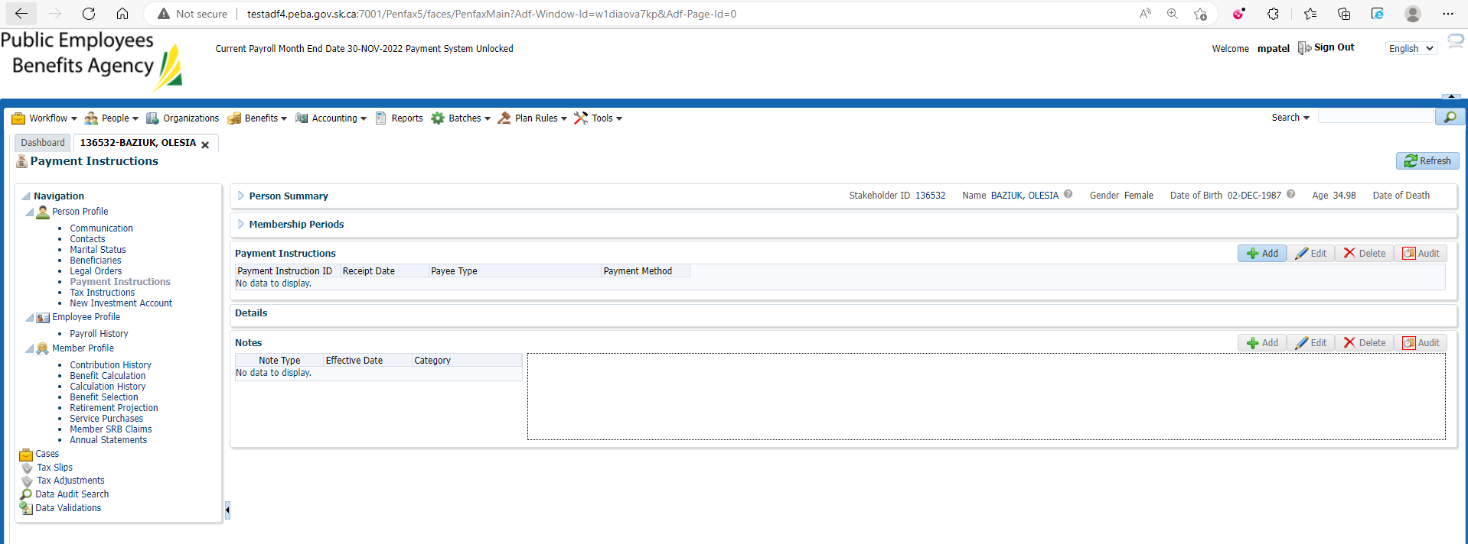

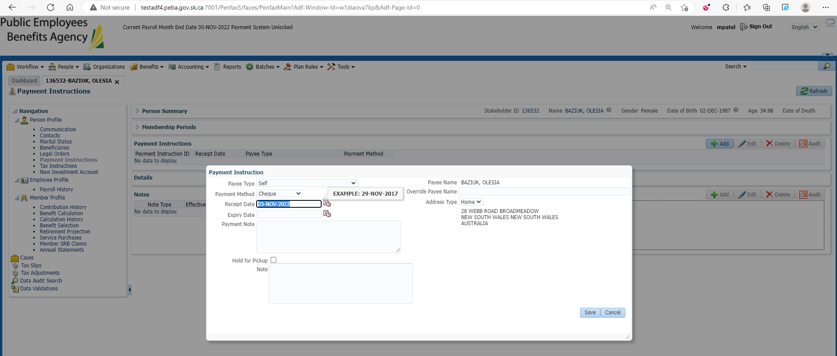

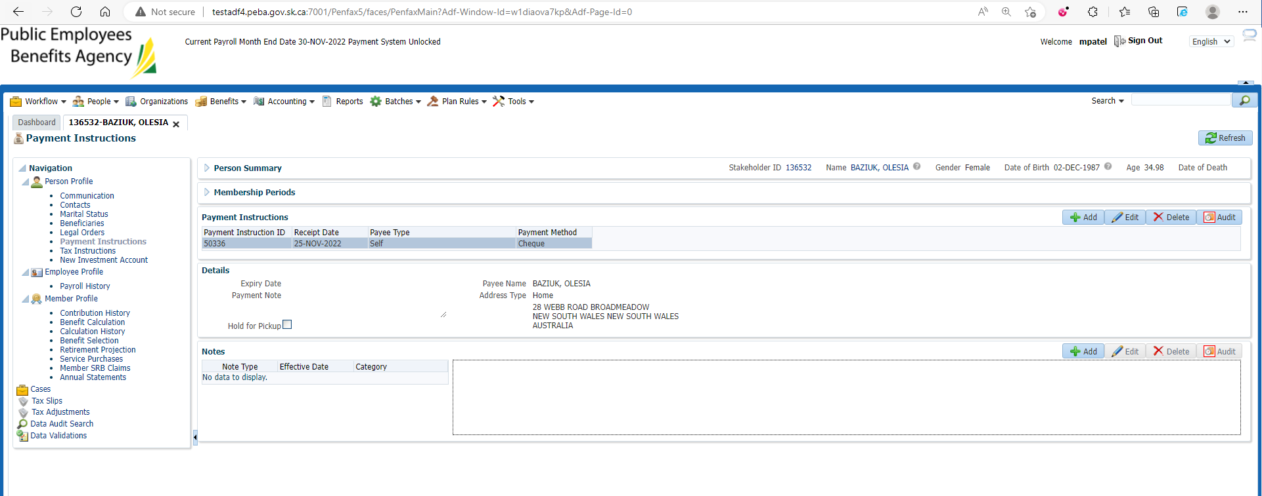

Benefit Selection🡪 Next

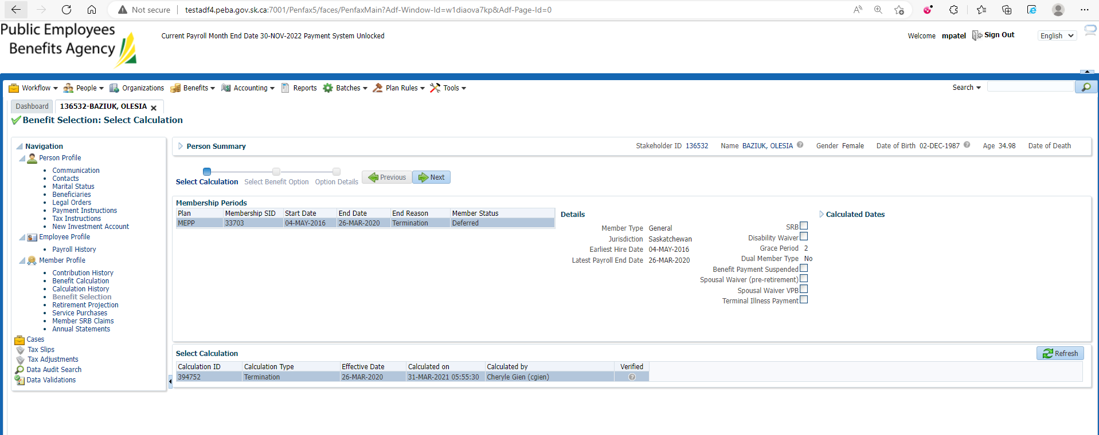

Enter new payment Date and Next

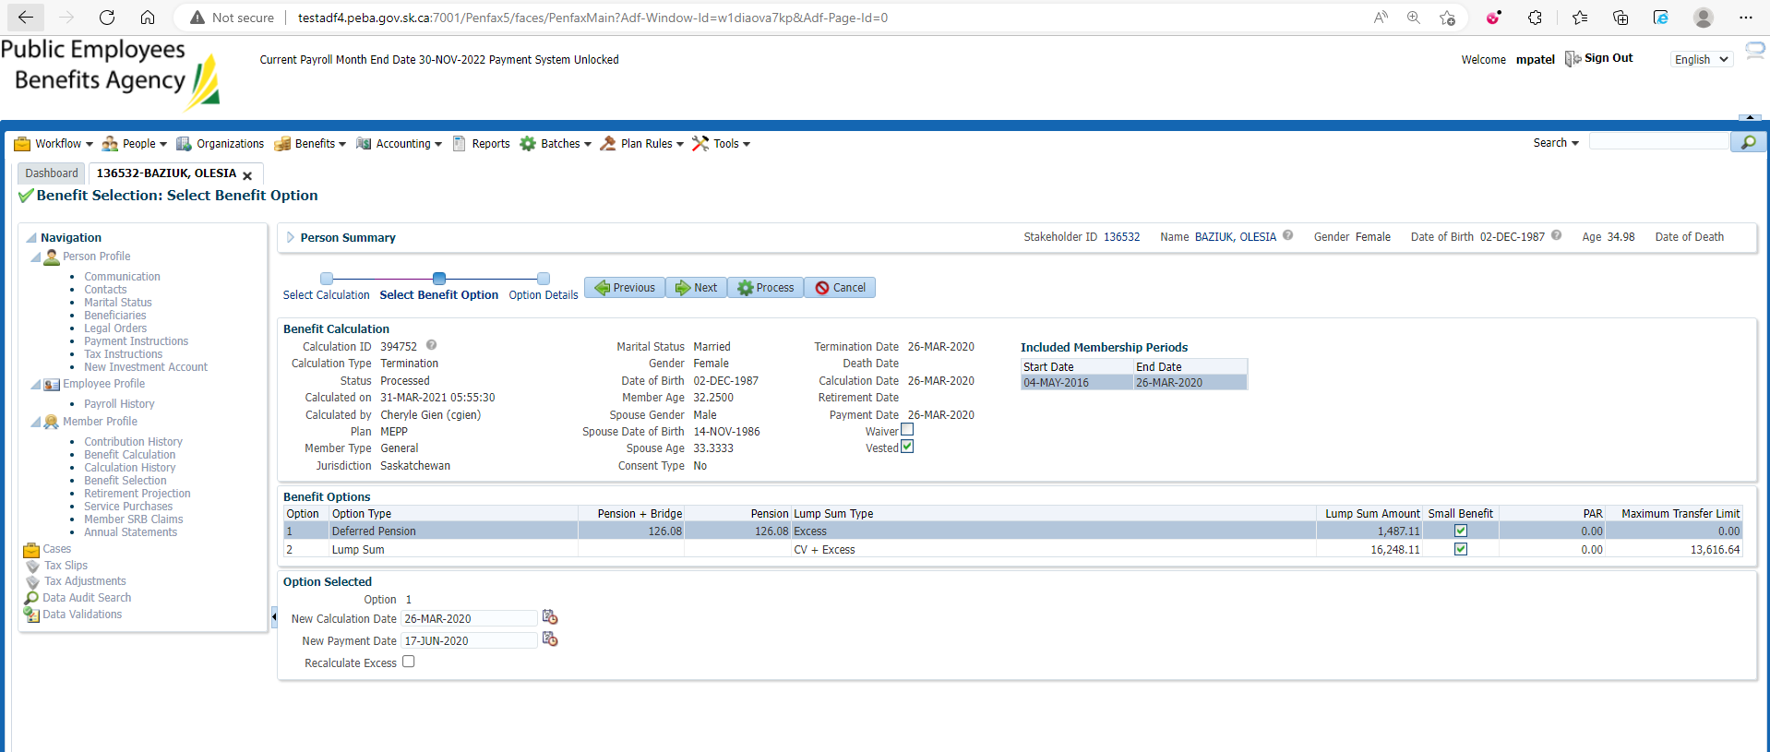

Process it

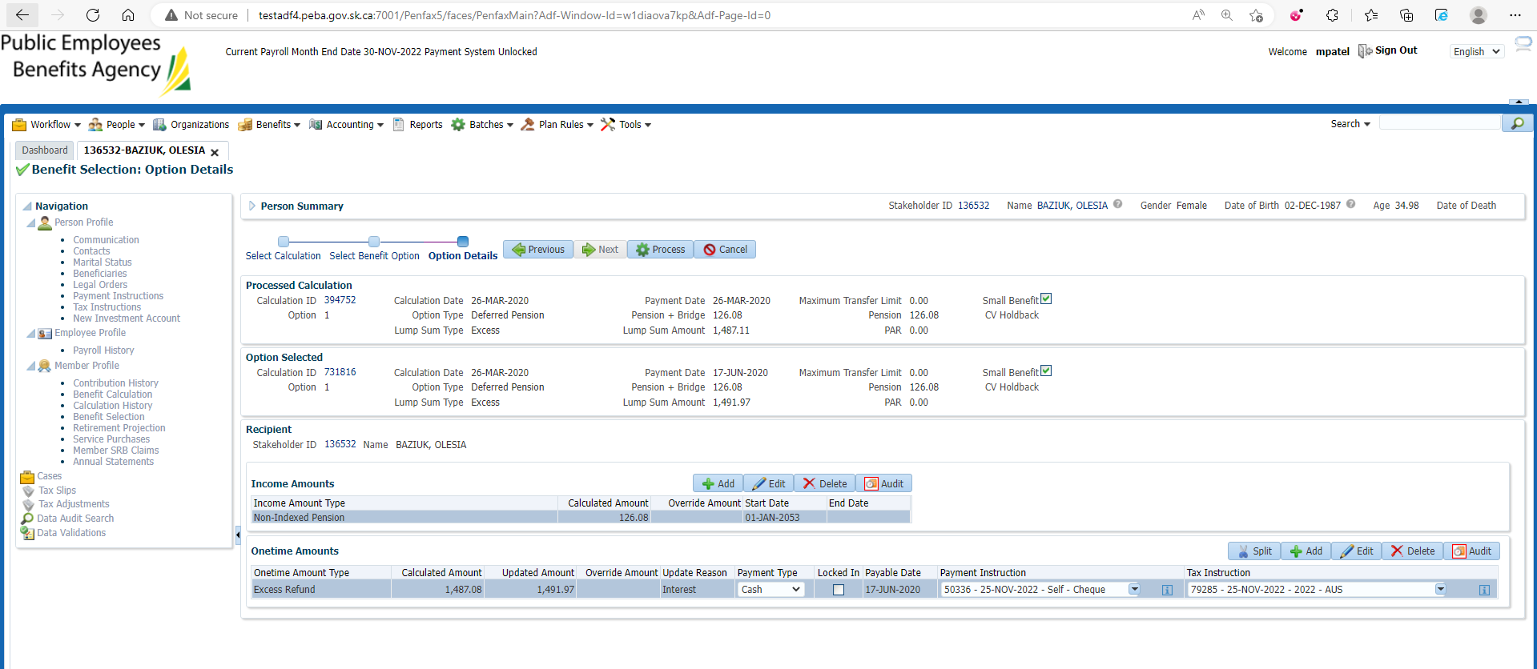

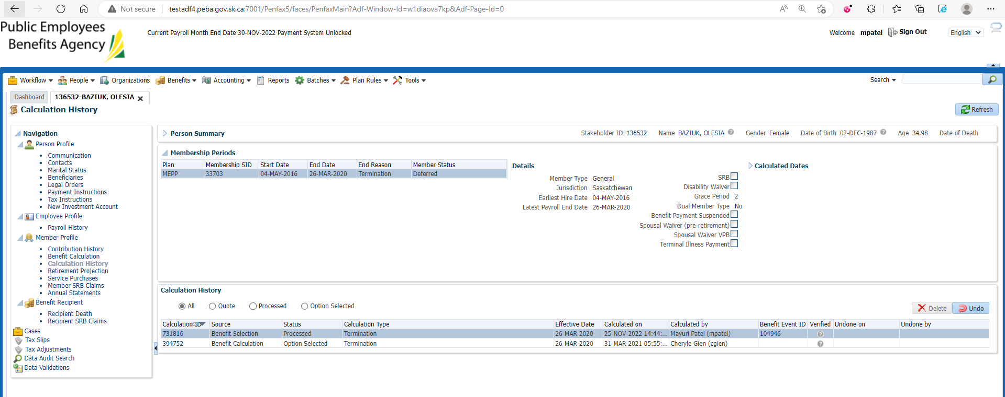

Under Benefit Recipient🡪 Onetime Amount Tab

Submit for Approval and Approve it

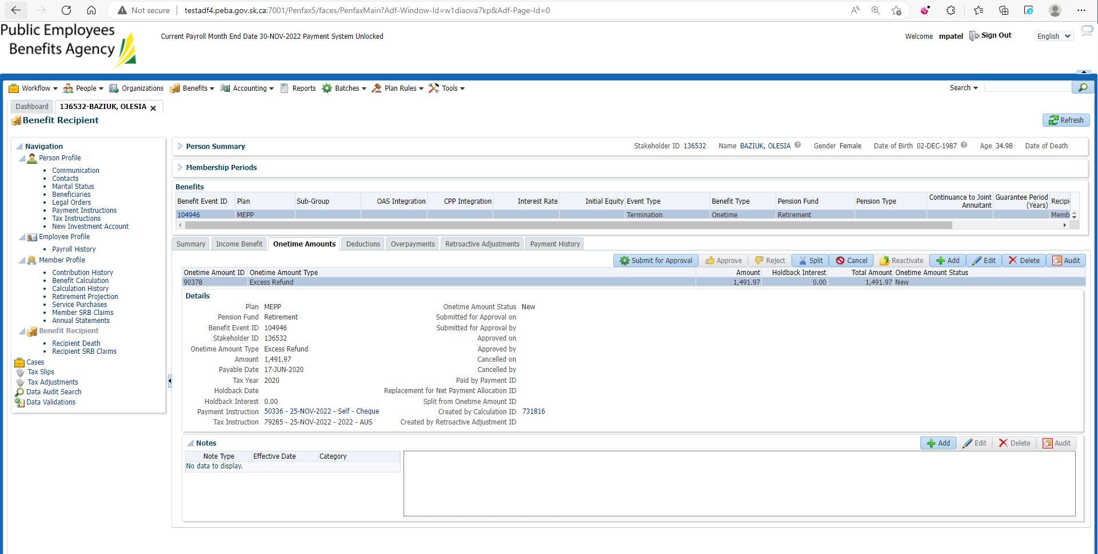

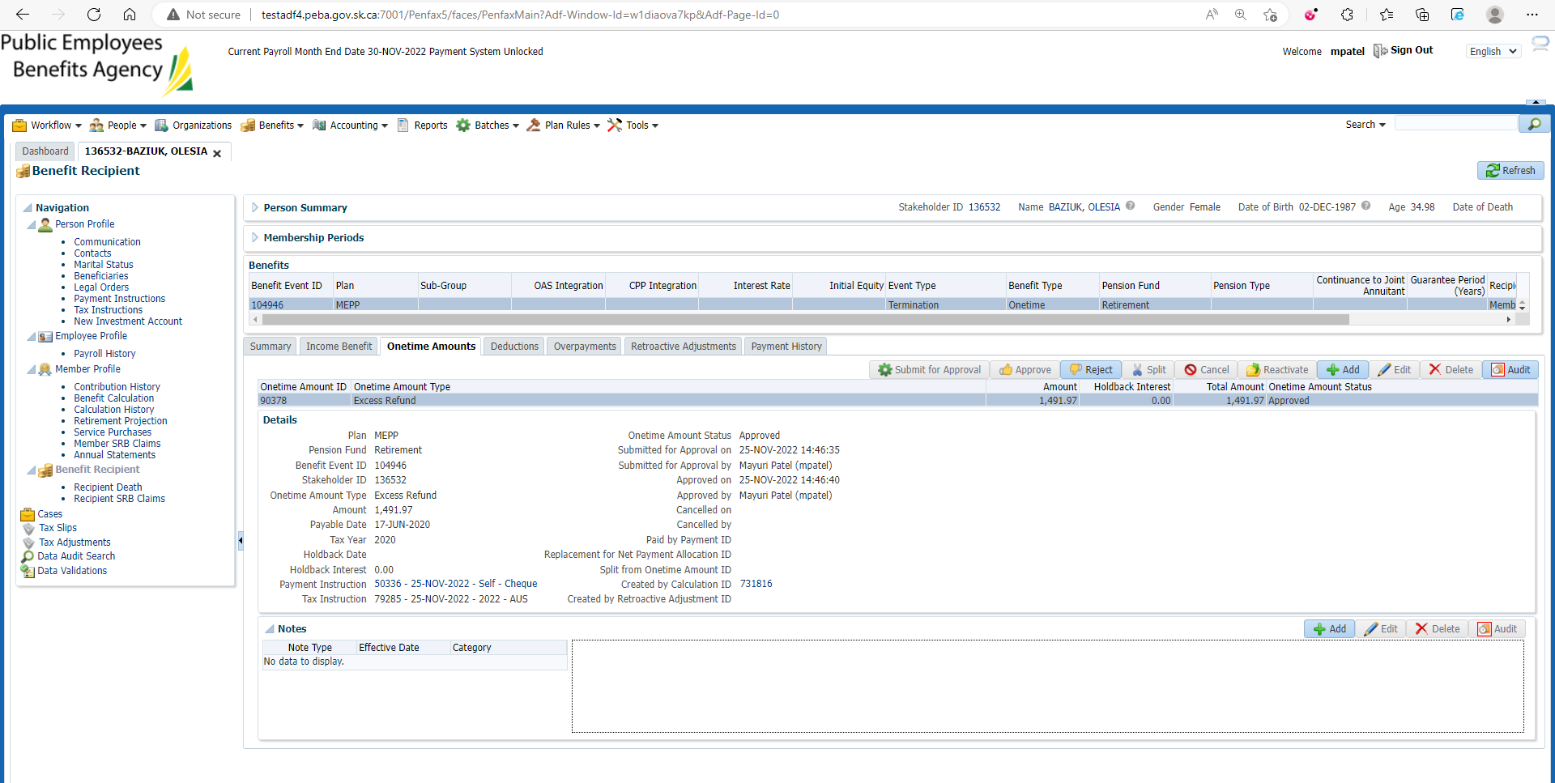

Under Summary tab Authorize the payment

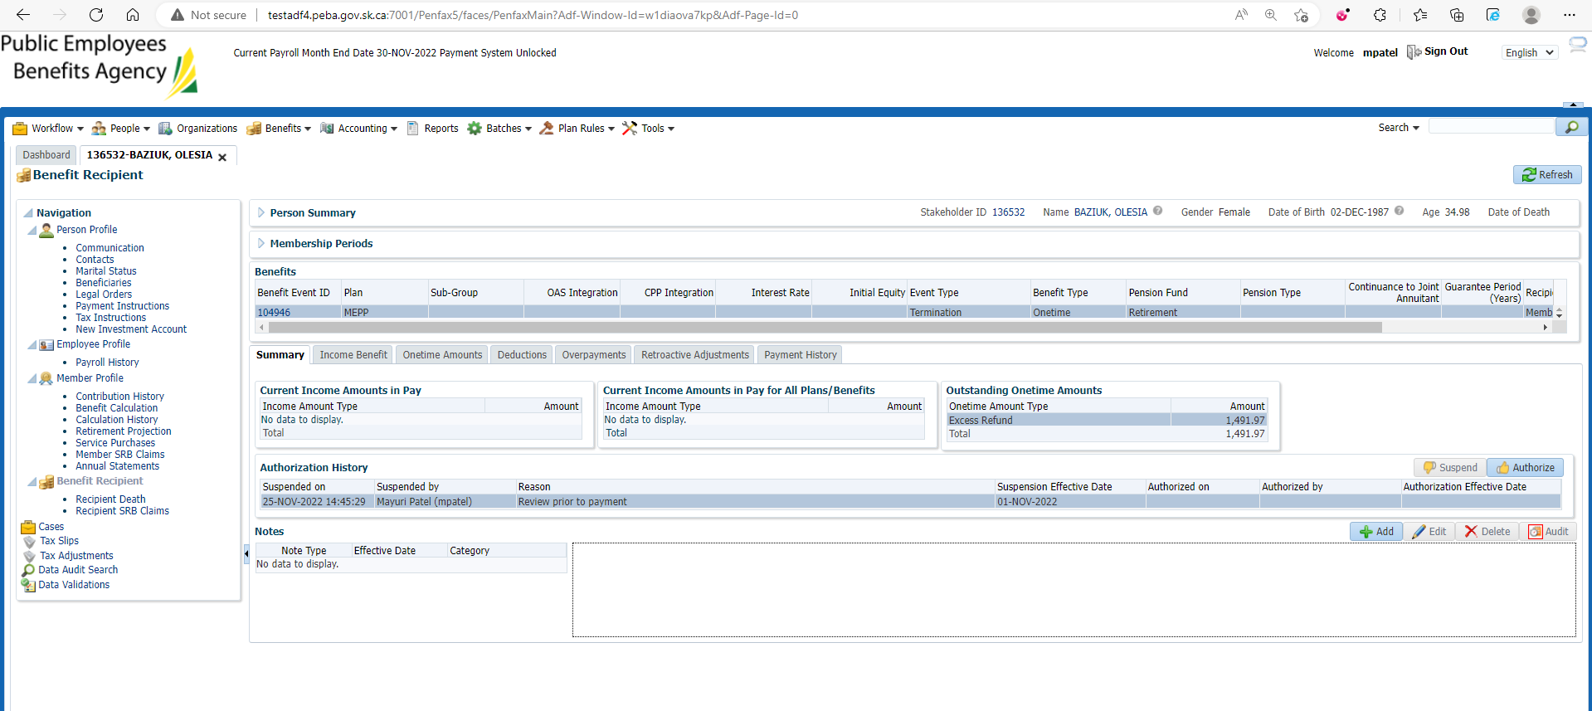

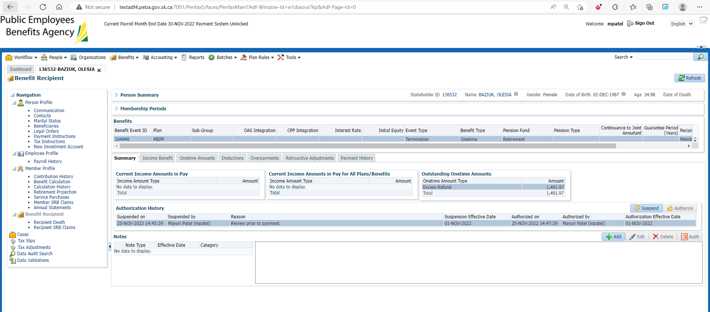

After payment Batch

Open that member profile again

Go to Benefit Recipient🡪 Onetime Amount

Payment is processed and paid out

